Plant Heritage Threatened Plant of the Year 2024
to be showcased at RHS Hampton Court Palace Garden Festival

At Plant Heritage we are keen to showcase rare and unusual plants, and we have the perfect opportunity for you to display your own threatened plant in our ‘Threatened Plant of the Year’ competition.
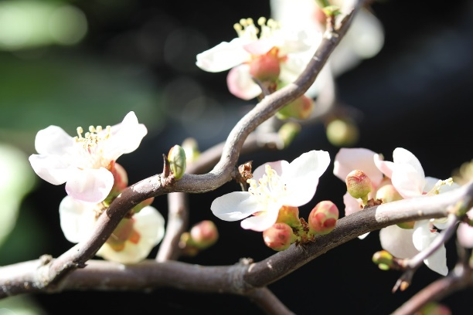
The winner in 2023 was Chaenomeles speciosa 'Contorta', chosen for being attractive throughout the seasons due to the apple blossom flowers and the twisted branches. It also has cultural heritage from its long history of being grown in the UK.
The public vote was won by Rhododendron 'The Dowager', from the recently accredited National Plant Collection of Loder rhododendrons at Leonardslee Lakes and Gardens in Sussex.
See all the shortlisted plants in 2023.
2023 WINNER: Chaenomeles speciosa ‘Contorta’

Could you receive the 2024 Threatened Plant of the Year trophy? The criteria are:
- It should be a named cultivar (such as Aspidistra 'Irish Mist' or Begonia 'Patricia Furness)
- The cultivar should have existed for at least 10 years: either grown in a garden, or available from nurseries before 2014
- It should not be regularly available for sale

Applications, including a photo of the plant, can be submitted to Plant Heritage by an online form which will be available on our website. We would love to hear about the history of your plant too, which could include information about the breeder, its association with people or places, or what makes this plant special to you.

The process:

- applications to be submitted by 19th May 2024
- all applications will be checked for eligibility against our Threatened Plants Programme data
- applicants will be notified in early June as to whether they have been shortlisted and that their entry will be invited for display at Hampton Court. All entrants are invited to the announcement of the winning plant, held at RHS Hampton Court Palace Garden Festival
- the RHS Hampton Court Garden Festival runs from 2-7th July. Either the plant, or a good quality photo of the plant can be displayed
- the winner will be judged by a panel of horticulture experts and a public vote will run for the duration of the show

We look forward to receiving your applications and to hearing about your threatened plants. If you have any queries please get in touch through collections@plantheritage.org.uk.

